Feedback Document: March 9, 2026 / Randy Duguay
GP / Admin Flow Screens
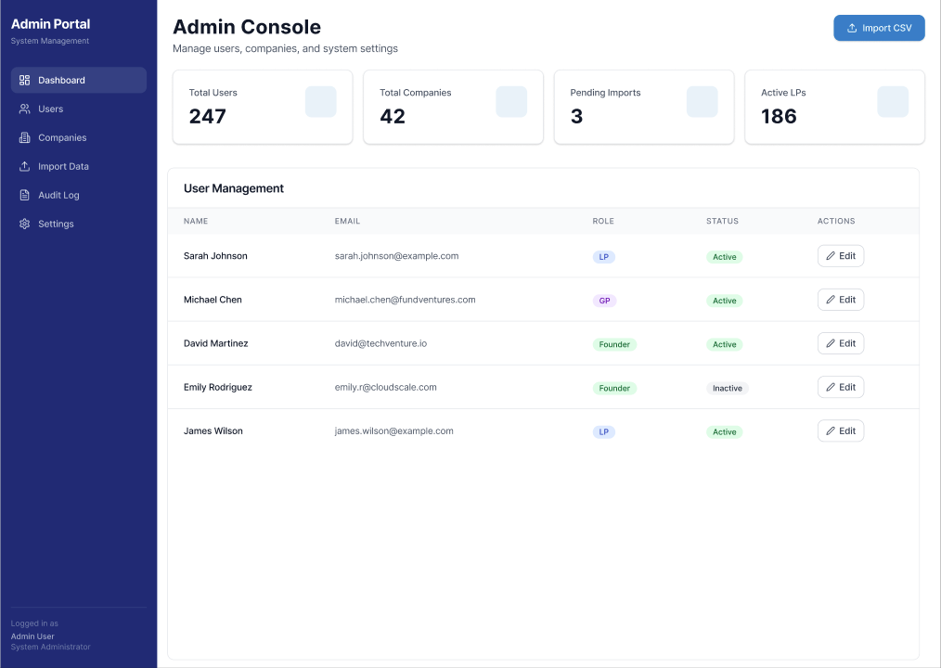
Screen GP1: Admin Console
March 9, 2026: Note that the Admin (or what I am referring to as more of a Super-Admin) screen is one that manages access rights regarding the GP-Level (i.e. a level above TNT) is where we (V8T.V support) manages the rights of the GP Organization (and their top-level) resources (contacts). At this level, we would indicate who (at TNT, for example) would be indicated as GP (Admins), but we (V8T.V) would also have access to helping manage or address ‘ALL’ users within the system. The reason I mention this is because the system could be used for managing multiple locations within an organization (i.e. TNT-Edmonton, TNT-Calgary etc).
- Users (User Management) should also have: phone numbers, Organization
- Edit field should provide a means of resetting password, or updating records
- Roles could include: Super-Admins; GP-Admins; GP, LP, Founder

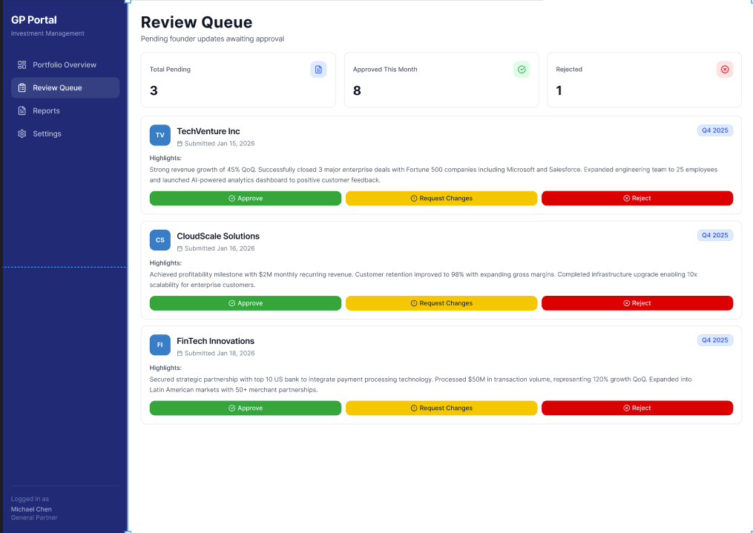
Screen GP2: Review Queue
On the Left Menu: I think we should have an icon (link) for ‘New Investment’ where the GP would be able to enter in the core information relating to investment into new company; we would enter in all the key information and setup the company access tools (Company account ID, and core materials). We would also want to have an ‘Update Investment’ link where the GP could update that company, add new investment reference materials.
NOTE: I don’t think that there would be a ‘REJECT’ button… so just the other two buttons are fine for now
Portfolio Overview Screen (not currently indicated):
- For this screen we will want to include a means of accessing: Initial Tear Sheet, DD Team information (contacts), and who invested (i.e. GP Fund, Summit Fund, LPs side-invest)
- Across the topline of each company (proposed for Portfolio Review), in addition to company name would be good to have the following information:
- Year invested – Year 0 Valuation – GP Investment – Current Estimated Valuation
- Side Menu item: There should be an item ‘Add Fund’ and that next page would be where the GP could (a) Create a Fund, and for that fund, LPs could be added for record; OR, (b) Create a Summit, where LPs could be added for that Summit; OR, (c) Create a Side-deal, again where LPs could be added for that side-deal (individual company investment)
  - Note: Once a Fund OR Summit OR Side-deal has been created, it can (recommended) to have a unique ID number for that envelope (fund).
  - Modifications to the Fund / Summit / Side-deal, would only be modifiable via the ‘Update Fund’ menu item
- Side Menu item: There should be an item ‘Update Fund’ where the Fund/Summit/Side-deal might be modified. For next screen, modification would have a field indicating notes on what the modification was, and the Fund/Summit/Side-deal, could have a version number (and date) associated for record, and who made the modification.
  - Modifications might be editable to address material changes to the Fund/Summit/Side-deal
  - It would be a plus to be able to associate a related PDF, if appropriate – for record of the modification.
- Side Menu item: There should be an item ‘Close Fund & Distribution’ which would indicate that a Fund was closed (exited) and that there. We can leave this as un-defined for present and provide more details later.

Founder Flow Screens
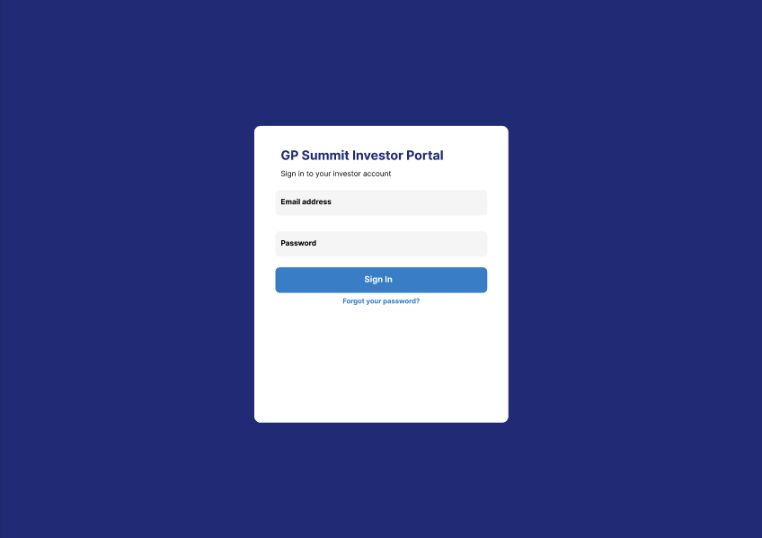
Screen F1: Login Screen
We’ll probably also include some links for: * Terms of Service * Privacy

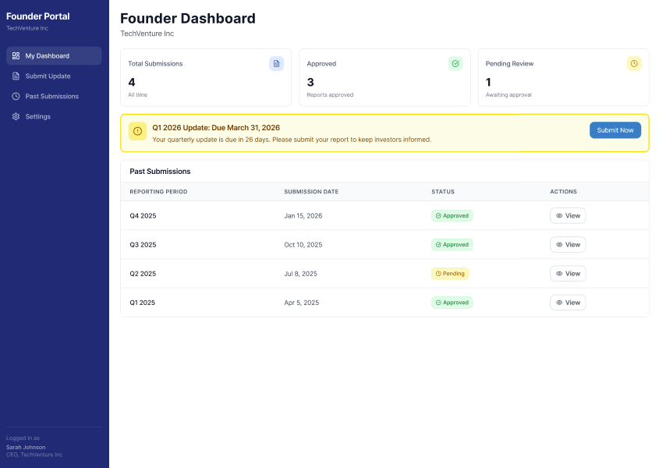
Screen F2: Dashboard Screen
No comments for now.

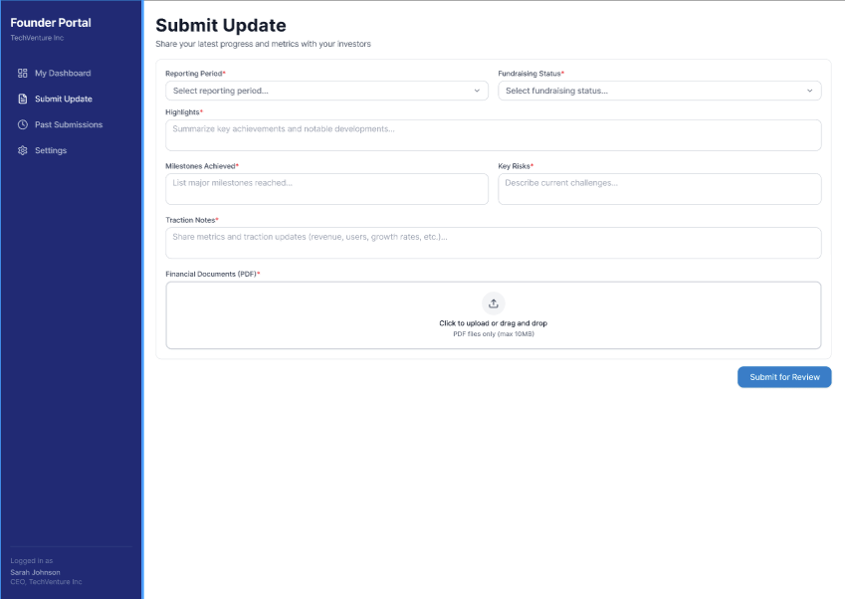
Screen F3: Update Submission Screen
- We will want to think about where we have a button (idea) for GP to make a request for update to the portal… maybe a different screen somewhere?
- Consider some type of automated email reachout to Founder email contact… might be a future item
- For this screen, other fields could include (a) Revenues in this period; (b) Expenses in this period; (c) Field for indicating milestone objectives for upcoming period.

LP Flow Screens
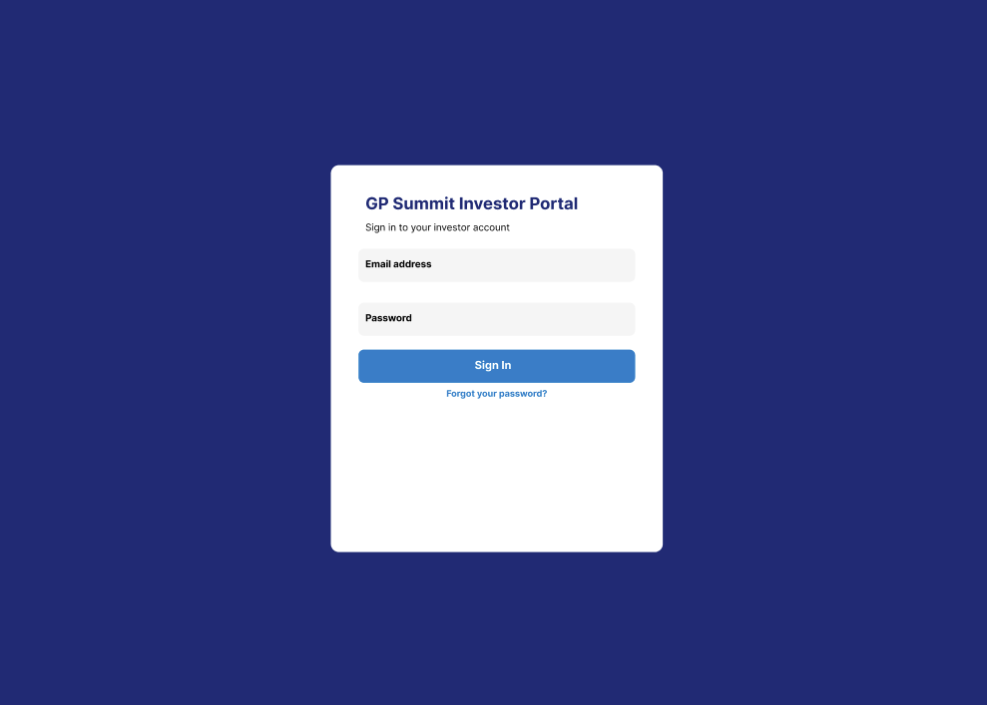
Screen LP1: Login Screen
We’ll probably also include some links for: * Terms of Service * Privacy
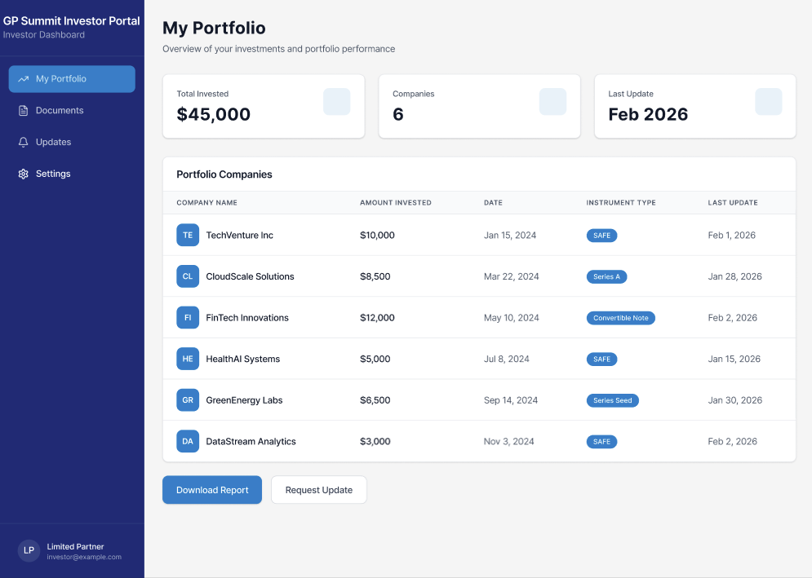
Screen LP2: Portfolio Screen
We should have a columns regarding the amounts being: (a) Company Name; (b) GP invested; (c) LP invested; (d) Fund Reference; (d) Instrument Type; (e) Investment Start Date; (f) Last Update
- Note that the investor may have invested using multiple types (i.e. Fund, and Summit, and Side-deal) in which case there might be three separate records for the same company but all indicated to the three different fund-types… that is ok… as each fund-type will also have different ‘subscription’ or ‘GP’ related subscription documents associated with each record
  - Where the LP has multiple records for the same company, we could have that indicated as a total amount as well (per company) / so something to consider
- Noted, while I provided some information on how to indicate valuation (metrics) / we do not need to get into this for this current stage of work.
  - We could provide for a side menu item (disabled / un-developed) for ‘Valuation’ which is something that we will put more definition to in future (future stage).
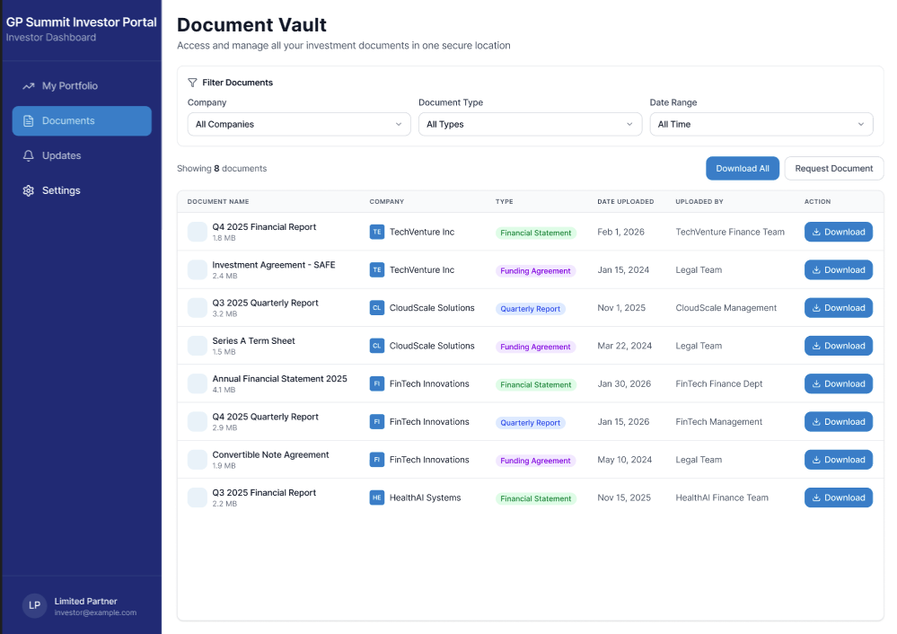
Screen LP3: Document Vault
Let’s hold on this screen for now. I like this conceptually.
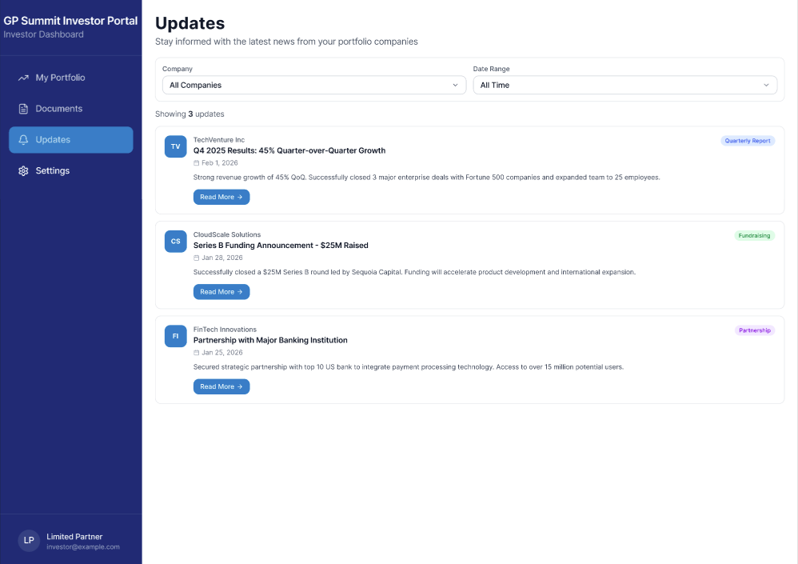
Screen LP4: Updates Screen
Let’s hold on this screen for now. I like this conceptually.

